# Failure is Inevitable in Care Activism

### Lekshmy Parameswaran

I’m a care activist, designer, and the co-founder of a mission-based design practice called The Care Lab (www.thecarelab.org[)](http://www.thecarelab.org/). After witnessing systemic failure in our care systems, structures, and services we set up The Care Lab. Our intention is to put care back into our systems of care by designing compassionate, proactive, and equitable experiences for people. After working internationally for more than two decades to transform the landscape of care — from social care to healthcare and education — I have found it to be both a joyous and messy terrain, one where systemic failures can often coexist alongside incredible humanity and hope.

In this chapter I explore some of the key crucial intersections between failure and care that have informed my care activism approach. Through three case studies I seek to provide critical reflection. Throughout the chapter I seed key failure provocations as points for critical reflection for care activists.

*Can our biggest societal failures provoke us to rise up to become our best selves?*

Our mission as care activists is to design new models of care that shift the status quo, so by default the work is disruptive. We at The Care Lab therefore encounter failure on a regular basis and I have many beautiful scars to prove it. Our approach typically involves layering different forms of qualitative design research.[1]

We develop participatory methods and tools to help us deeply understand the experiences and needs of people involved in any given care experience.[2] This may include frontline care teams, patients, family caregivers, and their communities, as well as private, public, and non-profit care provider organizations. Since the work is about systemic change, we increasingly find ourselves working alongside city councils and local or national government teams whose decisions shape our experience of care.

## Systems of Care

Developing new methods and tools to facilitate a creative and constructive dialogue between providers and receivers of care lies at the core of our practice and is what drives our design process and outcomes, be they new services, spaces, programs, and/or tools.[3]

The health and care domain is naturally a risk-sensitive environment where safety is of utmost priority. Careful ethical, technical, and clinical protocols and requirements frame our work. The environments in which care happens — be it nursing homes, hospitals, community centres, or individual homes — are by default unpredictable and uncertain given the complex situations, emotions, and processes at play.[4]

For instance, this may include a family grappling day-to-day with a son’s severe physical and mental disabilities; a community self-organising to support their vulnerable elders; a social worker hosting an end-of-life conversation with a resident in denial of their disease; or an oncologist delivering the news of a terminal cancer to a patient and his distraught partner. As much as we might carefully plan our research and design interventions in advance, we always need to be ready with a Plan B, C, or even D. Our tools must enable us to respond quickly, flexibly, and tactfully to what is always a dynamic context of care. Adaptation is not the result of failing to be prepared, but a way to build resilience and retain agency in the face of change.

We choose to explore some of the most challenging and taboo topics in care, such as death and dying or severe disability, topics that require us as professionals to confront our preconceptions and fears and sensitize ourselves.[5] We must not get in the way of our own listening, learning, and understanding of others’ pains, fears, and desires when it comes to their experience of health and care.

As a care activist, I feel a deep responsibility *not* to fail people who are already being failed by our institutional systems of care. And yet I know that failures are inevitable when we are trying to change a complex system. That’s why I always wonder whether instead of trying to avoid it, we should rather embrace failure through our creative and transformative practices.

## Failure Can Be a Creative Force

Reflecting on the diverse experiences we have had in different continents, cultures, communities, and care systems over time, we have developed specific design research strategies, methods, and tools that turn a fear of failure into a practical asset. This includes tools to minimize risks and avoid doing harm during research, techniques to reframe errors as opportunities to reflect, and methods to deepen empathy and/or connection.

There is a need to liberate ourselves as care activists from the fear of failure that can at times prevent us from being as bold in our actions as we could be.[6] We have created simple but powerful rituals as a design team for working through such deep-rooted fears; a repository of methods and tools that help us to fail creatively and with a sense of confidence. This helps foster an attitude of creative reframing when it comes to thinking about risks, uncertainties, failures, and the act of failing itself.

## Towards a Failurists’ Toolkit: Three Projects

As a design practitioner I want to share three project stories with inherent risks of failure, coupled with three practical and creative interventions we discovered could help us embrace failure when conducting sensitive design research or systemic transformation. Even though these practice rituals are born from our work in the care space, you might consider them relevant for any work that strives to unpack a complex and sensitive topic or tries to achieve greater, more systemic impact. Take them as inspiration and starting point. There are surely many more practices and techniques possible to play with failure in a similar way.

*What are you most fearful about within a current research topic and how does this affect your approach to the work?*

## Failurist Practice 1: Empty Your Backpack // Self-awareness and Sensitization

**Project:** *Hospitable Hospice*, Singapore, 2013. In partnership with the Lien Foundation, Ang Chin Moh Foundation, Dover Park Hospice, Assisi Hospice, and St Joseph’s Nursing Home and Hospice.[7]

**Intention:** To reimagine the end-of-life experience of in-patient hospices in order to celebrate life at the end of life.

**Potential Risk:** Not being able to listen fully and deeply to people due to our personal fears and misconceptions of death and dying.

**Practice Story:** We came together as a team at the start of the project to understand the human experience of death and dying. It was the first time we had deep dived into this topic, despite it having been in the background of much of our work in health and care. Reflecting upon our individual fears and hopes related to death, we wrote them down on pieces of paper or chose specific objects to represent them. Taking turns, we expressed our fears to one another and placed the paper or object into the box. We saw we had similar fears and were not alone, but we also saw how we could better support one another, as sharing our vulnerabilities made us stronger as a team, and therefore be better prepared to enter this confronting topic and uncertain territory.

At the end of the session, we closed the box with a collective intention to place our own preconceptions and hopes to one side and make space in which to deeply listen to the stories of patients, families, and professional caregivers facing end-of-life. We also found a vocabulary amongst ourselves, and new ways to open a conversation around death and dying that we could then apply in our research with terminal patients and their loved ones.

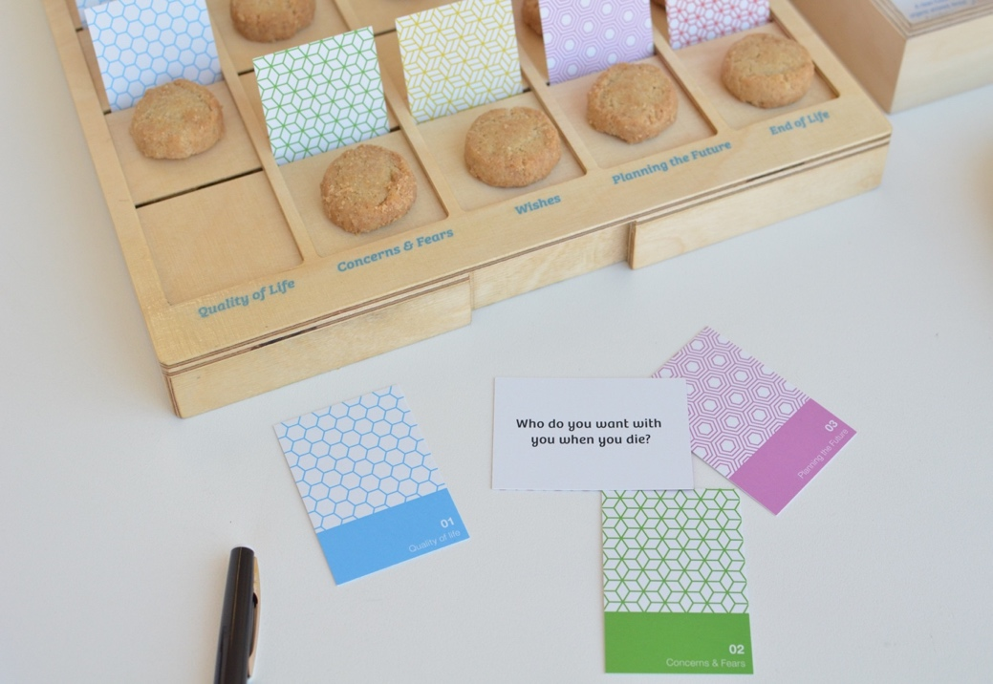

Figure 12.1: Empty Your Backpack: A conversation toolkit to open up and reflect upon end-of-life fears, hopes, and preconceptions. Image credit: The Care Lab.

*What Red Flags (warning signs) do you see on your project horizon and how could you prepare to navigate them?*

## Failurist Practice 2 : Red Flag Protocol // A Partnership Practice for Transformation Projects

**Project**: *Care Beyond Walls*, Singapore, 2021-ongoing. In partnership with the Lien Foundation, AWWA Health & Senior Care, Trisector Associates, and IELO Architects.

**Intention:** To demonstrate a new community-based model of dementia care that creates the conditions for persons with dementia and their caregivers to thrive within their neighbourhood.

**Potential Risk:** To overly focus on the bold, aspirational goals of the project and neglect to monitor the multiple and messy factors that are difficult to control but that can be crucial for project impact.

**Practice Story**: The kick-off of any new partnership project tends to focus on creating a positive vibe amongst everyone convened and a recap of the group’s shared objectives. But when the work involves implementing a new model of care in a sector where standards of care have been well established and deeply embedded for decades, there is a need to acknowledge the very real risks and pain that might be felt in any process of transformation.

So aside from asking everyone’s expectations and personal motivations for the project, people shared the risks they saw and the potential failures we may face along the way. These were captured alongside the hopes and without judgement or shame. We created the idea of a Red Flag Protocol that would support a team ritual of reflecting on risks at key moments in the project, and gave permission for any partner to raise a Red Flag, so that it could be discussed collectively and either mitigated or used to better prepare us to navigate the uncertainty.

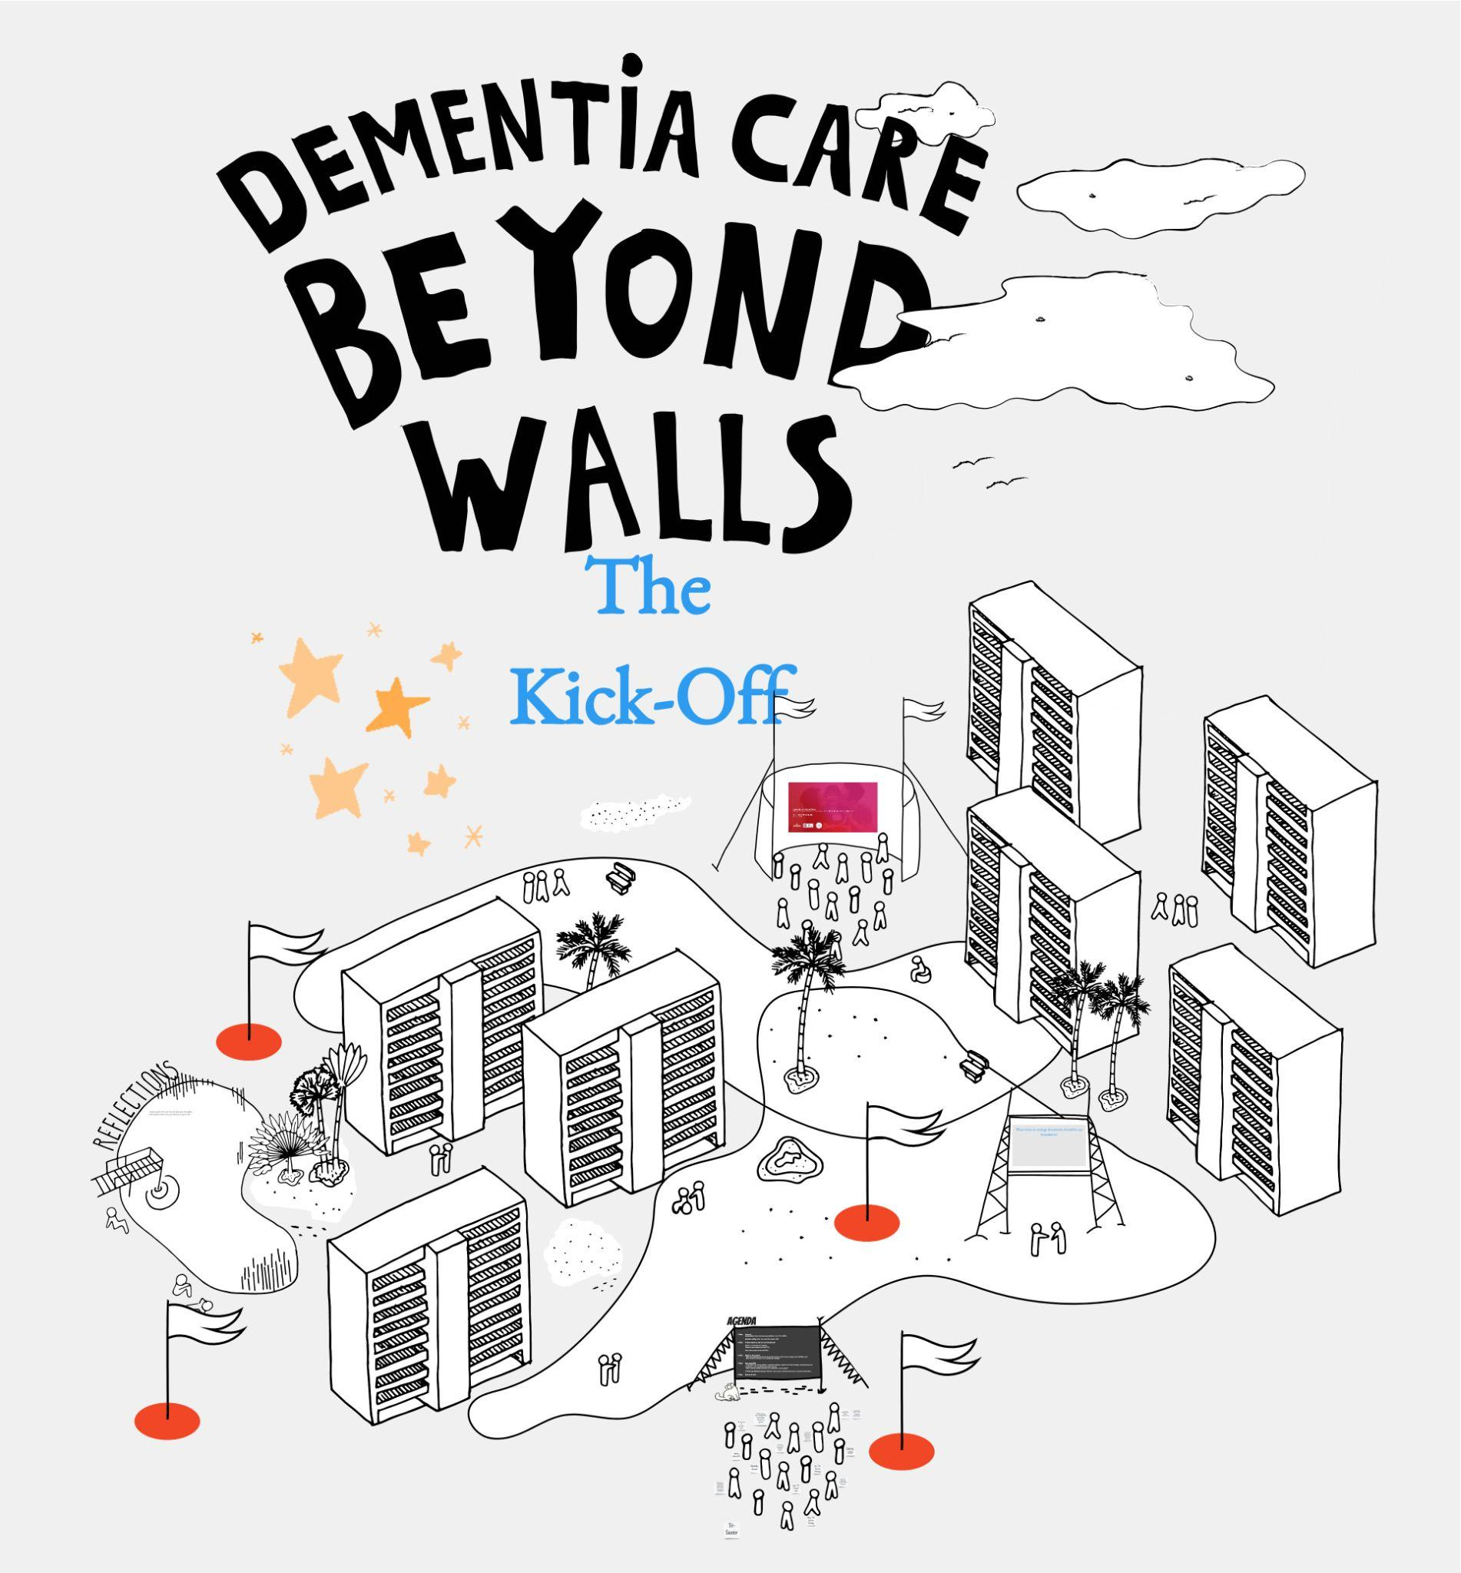

Figure 12.2: Care Beyond Walls Kick off Meeting Space: Online space where the project partners can safely share expectations as well as identify and discuss potential risks and failures of the project. Image credit: The Care Lab.

*What levels of zoom (into lived experience) might you need to confidently play inside your research landscape?*

## Failurist Practice 3: Combining Levels of Zoom // A Layered Research Strategy

**Project**: *Who Cares? Singapore,* 2016. In collaboration with NCSS (National Council of Social Services).[8]

**Intention**: To uplift and support the role of the family caregiver and transform the experience of caregiving.

**Potential Risk:** The caregiver is often an invisible ‘red thread’ connecting disparate services across the health and social care landscape. Understanding their needs and challenges means understanding this complex landscape at multiple levels simultaneously including policy, system infrastructure, and service touchpoints as well as community and family-based lived experiences. The danger lies in missing a crucial piece of this vast and detailed picture and thereby failing to find the most significant opportunities to provide support to and serve the needs of caregivers.

**Practice Story**: It was important to work at different scales of insight for such a transformation project. We created a Landscape Map (Figure 12.3) that acted as a visual framework with which we could see the caregiving journey across various silos and sectors, placing key service providers and resources into the picture. This helped us to have a panoramic-level of zoom and to identify where the systemic gaps in caregiver support were. Video ethnography (Figure 12.3) was then used as the most intimate, eye-level of zoom to reveal gaps in supporting lived experiences.[9] We spent hours accompanying and getting to know ten different families each struggling with complex caregiving situations, creating a set of films documenting and revealing the seven emotions of caregiving.

These lived experiences revealed the impact that the overarching system of policies, structures, and services were having on caregivers’ quality of their life. A research toolkit that enabled us to achieve different levels of zoom helped to hold the bigger picture in mind, even whilst empathising at the most fundamental human level; it held the complexities and uncertainties, whilst also giving us room to reflect, explore, play, co-create, iterate, and design with the confidence that we could thereby define a more holistic and complete ecosystem of new support solutions and strategies.

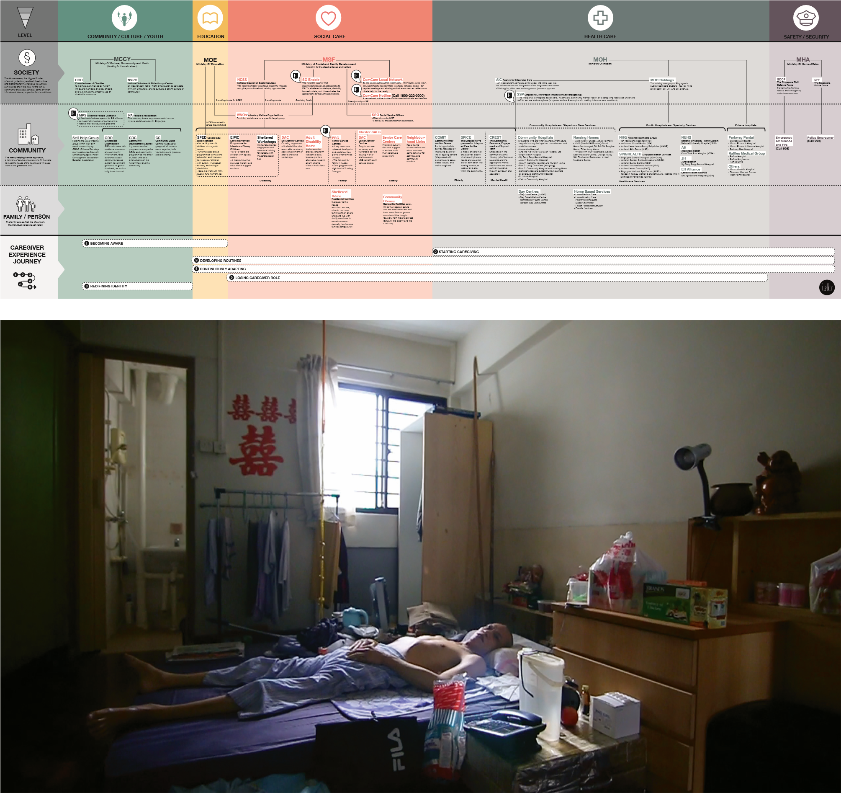

Figure 12.3: Landscape Map and movie still (side by side). Landscape map of caregiving support in Singapore (left). Mr. Neo, one of the patients we accompanied during the video ethnographic research. (right). Image credit: fuelfor/The Care Lab with National Council for Social Service.

## Failure Can Build Our Capacity to Drive Change: Personal Reflections

I have provided three projects in which care and failure have been part of the critical making and reflection. As I have suggested, while practitioners might be learning to be more comfortable (and less fearful) around failure and failing, knowing its power to drive creativity, this approach seeds a series of further provocations.

How do we convince communities, organizations, and funders to commit time, money, and effort towards a cause?

How do we demonstrate that it is possible to reimagine new systems of care by offering a process of social innovation and a toolkit of design research practices that can be trusted to navigate risks and complexities and facilitate the creativity needed to achieve social impact?

How do we apply such practices to empower ourselves, our teams, and our partners to see failure as natural consequence of such structural transformation, and yet also build the confidence and spirit to work productively and playfully in spite of the risk of failure and the consequences of failing?

As a practitioner and care activist I believe that if we can answer some of these questions related to failure, we may discover more effective ways to spread and scale new models of care, and thereby help to drive forward a social movement to transform care.

Our systems of care are broken, it *will* take courage to redesign them.

On a more personal note, I think it is important to stay awake to the fact that you can still fail even after working for decades in a specific area or topic. In fact, experience can make you confident to be bolder, to risk failing more spectacularly in order to achieve a greater impact. But it can also make you complacent and less exploratory or playful, relying on past deep experience. So, I feel that by learning to acknowledge and work constructively with failure, you can ensure that you stay humble and yet always open to learn and grow.

So, wear your scars with pride.

## Bibliography

Aralas, Dalia. ‘Extending Video Ethnographic Approaches’, in *Methodological Developments in Ethnography*, Bingley: Emerald Group Publishing Limited, 2007.

Coughlin, Sheryl, Roberts, David, O’Neill, Kenneth, and Brooks, Peter. ‘Looking to Tomorrow’s Healthcare Today: A Participatory Health Perspective.*’ Internal Medicine Journal*, 48.1 (2018): 92-96.

Delbrassine, Nathalie, Dia, Oscar, and Escarrabill, Joan. *The Patient’s Perspective in the Health Care System. Shared Patient Experience*. Brussels: SPX, 2020, https://spexperience.org/wp-content/uploads/2021/01/SPXPositionPaper_EN.pdf

Haian, Xue, and Desmet, Pieter M.A. ‘Researcher Introspection for Experience-Driven Design Research’, *Design Studies* 63 (2019): 37-64.

Heller, Steven. *Design Disasters: Great Designers, Fabulous Failure, and Lessons Learned*, New York: Simon and Schuster, 2008.

*Hospitable Hospice. Redesigning Care for Tomorrow*, Fuelfor, Lien Foundation and ACM Foundation, 2013, https://www.thecarelab.org/hospitablehospice

Lunenfeld, Peter. *Design Research: Methods and Perspectives*, Cambridge: MIT Press, 2003.

Raisio, Harri, Puustinen, Alisa, and Vartiainen, Pirkko. ‘The Concept of Wicked Problems: Improving the Understanding of Managing Problem Wickedness in Health and Social Care’, in Will Thomas, Anneli Hujala, Sanna Laulainen, Robert McMurray (eds) *The Management Of Wicked Problems In Health And Social Care,* London: Routledge, 2018, pp. 3-20.

Sanders, Liz, and Simons, George. ‘A Social Vision For Value Co-Creation In Design’, *Open Source Business Resource*, (December 2009): 27-34.

Vishnu, Renjith. Renjulal Yesodharan, Judith A. Noronha, Elissa Ladd, and Anice George, ‘Qualitative Methods in Health Care Research,’ *International Journal of Preventive Medicine* 12 (2021).

*Who Cares? Transforming The Caregiving Experience in Singapore.* National Council of Social Service and fuelfor, 2016, https://www.thecarelab.org/whocares

1. Peter Lunenfeld, *Design Research: Methods and Perspectives*, Cambridge: MIT Press, 2003.
2. Much of our methodology is informed by the interdisciplinary approaches across health, care, and design. Some key relevant texts include:, Renjith Vishnu, Renjulal Yesodharan, Judith A. Noronha, Elissa Ladd, and Anice George, ‘Qualitative Methods in Health Care Research,’ *International Journal of Preventive Medicine* 12 (2021); Sheryl Coughlin, David. Roberts, Kenneth O’Neill and Peter Brooks, ‘Looking to Tomorrow’s Healthcare Today: A Participatory Health Perspective.’ *Internal Medicine Journal*, 48.1 (2018): 92-96; Nathalie Delbrassine, Oscar Dia and Joan Escarrabill, *The Patient’s Perspective in the Health Care System*. *Shared Patient Experience*. Brussels: SPX; 2020, https://spexperience.org/wp-content/uploads/2021/01/SPXPositionPaper_EN.pdf.
3. Liz Sanders, and George Simons, ‘A Social Vision For Value Co-Creation In Design’, *Open Source Business Resource,* (December 2009): 27-34.
4. Harri Raisio, Alisa Puustinen, and Pirkko Vartiainen, ‘The Concept of Wicked Problems: Improving the Understanding of Managing Problem Wickedness in Health and Social Care’, in Will Thomas, Anneli Hujala, Sanna Laulainen, Robert McMurray (eds) *The Management Of Wicked Problems In Health And Social Care*, London: Routledge, 2018, pp. 3-20.
5. Xue Haian, and Pieter MA Desmet, ‘Researcher Introspection for Experience-Driven Design Research’, *Design Studies* 63 (2019): 37-64.
6. Steven Heller, *Design Disasters: Great Designers, Fabulous Failure, and Lessons Learned,* New York: Simon and Schuster, 2008.
7. *Hospitable Hospice. Redesigning Care for Tomorrow*, Fuelfor, Lien Foundation and ACM Foundation, 2013, <https://www.thecarelab.org/hospitablehospice>.
8. *Who Cares? Transforming The Caregiving Experience in Singapore.* National Council of Social Service and fuelfor, 2016, <https://www.thecarelab.org/whocares>.
9. Dalia Aralas, ‘Extending Video Ethnographic Approaches’, in *Methodological Developments in Ethnography* Bingley: Emerald Group Publishing Limited, 2007.